CNT3004: Computer Network Concepts
Homework 4

(50 pts total) Answer each of the following questions and/or complete the required task. You will be installing some software on your system, but it is safe. Put ALL of your answers into 1 file (word, or pdf).

- (10 pts) List the classes of IPv4 addresses and their default subnet masks. In the final column list the number of host addresses per IP address and network addresses.
IPv4 CLASS & ADDRESSES | Default Subnet Mask | Total Number of Network Addresses Possible (one number) | Total Number of Host/Node Addresses Per Network Address (one number)
A  0.0.0.0-127.255.255.255 | 255.0.0.0 | 128 | 16,777,214
B  128.0.0.0-191.255.255.255 | 255.255.0.0 | 16,384 | 65,536
C  192.0.0.0-223.255.255.255 | 255.255.255.0 | 2,097,152 | 256
D  224.0.0.0-239.255.255.255 | None | None | None
E  240.0.0.0-255.255.255.255 | none | None | None

- (10 pts) Using the following IPv4 addresses, complete the information next to each address. You may need to use the following web site for help (the first IP address row is filled in so you know how to complete the table): https://www.tutorialspoint.com/ipv4/ipv4_addressing.htm
IPv4 ADDRESS | CLASS OF IP ADDRESS | DEFAULT SUBNET MASK | NETWORK / HOST ADDRESS
ex: 108.117.55.36 | A | 255.0.0.0 | 108.0.0.0 / 0.117.55.36
215.125.87.181 | C | 255.255.255.0 | 215.125.87.0/0.0.0.181
25.235.118.12 | A | 255.0.0.0 | 25.0.0.0/0.235.118.12
152.7.241.195 | B | 255.255.0.0 | 152.7.0.0/0.0.241.195
195.204.150.10 | C | 255.255.255.0 | 195.204.150.0/0.0.0.10
190.12.211.125 | B | 255.255.0.0 | 190.12.0.0/0.0.211.125

- (10 pts) Using TRACERT from the command line (prompt) enter the following web sites after the command, and record the specified data in the table below (first type tracert /? For help on the command and to see what the fields stand for). To stop the tracert, hold down the Ctrl key and press C.
Website URL | IP Address of destination | # of Hops reached in total to reach site or before “Request timed out” | Last IP address reached at end or before “Request timed out”
ex: www.ucf.edu | 34.231.210.198 | 7 | 99.83.64.116
www.stanford.edu | 151.101.194.133 | 9 | 151.101.194.133
www.amazon.com | 65.8.183.25 | 10 | 99.83.94.52
www.nfl.com | 151.101.1.153 | 11 | 151.101.153
www.publix.com | 23.199.7.84 | 13 | 23.199.7.84
www.target.com | 151.101.66.187 | 11 | 151.101.66.187

- (10 pts) Identify the following IP addresses and specify their slash notation for each address based on the corresponding subnet mask (these are all IPv4 addresses):
IP ADDRESS | SUBNET MASK | SLASH NOTATION | NETWORK ADDRESS
103.154.78.156 | 255.255.0.0 | /16 | 103.154.0.0
188.25.172.56 | 255.255.224.0 | /19 | 188.25.160.0
12.87.205.118 | 255.255.240.0 | /20 | 12.87.192.0
198.25.195.113 | 255.255.128.0 | /17 | 198.25.128.0
112.125.208.215 | 255.255.192.0 | /18 | 112.125.192.0
222.18.3.175 | 255.255.255.128 | /25 | 22.18.3.128

- (10 pts) Download and install Virtual Box on your computer by going to https://www.virtualbox.org/wiki/Downloads and selecting the correct version for your operating system (Mac, Linux or Windows). Once you have downloaded the program, run it and take a screen shot to show that it is functioning and place the screen shot below. Watch the following video on how to setup and use VirtualBox. Follow the directions for downloading and installing Ubuntu Linux in Virtual Box.
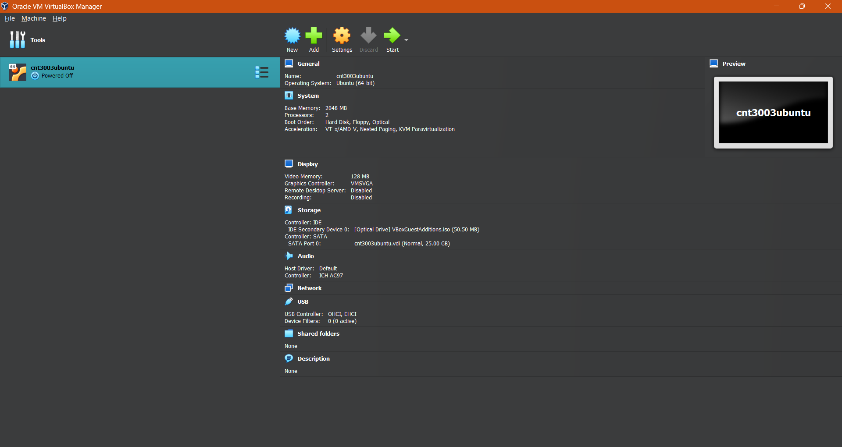

- https://www.youtube.com/watch?v=sB_5fqiysi4 (Video on how to use VirtualBox). Take another screenshot when you have installed Ubuntu in VirtualBox. That is all for now.
